Context based branch predictor

-Project report

Concept

Context based branch predictor is a new type of branch predictor influenced by the correlating branch predictor. The prediction is based on what instruction wrote the register using which the conditional jump is decided. So the instruction which is writing the registers in currently tracked. When the prediction has to be taken this tracked information is used to predict the target address.

Data structures to be newly added to the existing hardware

Instruction tracker:
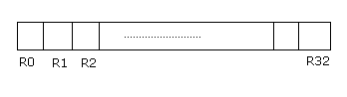

This hardware tracks the instruction which lastly updated a register.
For e.g.,

1000 add r2 ,r4,r5

this instruction causes the value of the R2 field in the data structure to hold the value 1000 which is the address of the instruction which currently updated the R2 register.
Separate structures must be used for integer and floating point registers.

Context based branch target buffer

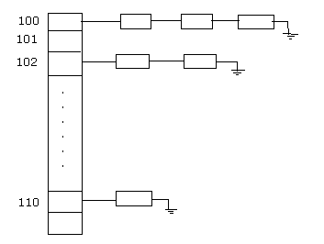
The BTB has two parts.

1. Hash table.
2. List of predictions hashed to the table.

The list nodes’ has following fields:
1. the target address. (TA)
2. the instruction which last wrote the conditional register ( the register using which branch will be taken or not taken). ( WRITER)

Algorithm

If an instruction is not a branch instruction,

Instruction_tracker[ target_register ] = current_PC;
Else
// it is a branch address
hash the current_PC to the hash table.
In list present in the hashed entry,
Check if there is an entry with WRITER = Instruction_tracker[ conditional_register].
If so return the TA in that node.
Else
Current_PC = Current_PC+sizeof (instruction).

Tournament predictor

Initially the new predictor is used as the default predictor. But as it becomes less performing the old predictor is used for some instructions. Additional structures are used for implementing the tournament predictor. 2 bits are used for tournament predictor.

Parameters used for evaluating performance

- Number of good predictions.
- Number of miss-predictions.
- Number of hits.
- Number of misses.

Simulation results

Improvements / Advantages

the new predictor has nearly 4000 good predictions than the old predictor for the tests- printf program.

The new predictor is used for most of the time when compared to the old predictor.

Disadvantage

The hardware is costly when compared to the older predictors.

COMPUTER ARCHITECTURE PROJECT

CONTEXT BASED BRANCH PREDICTOR

- simulation of the new hardware using Simple scalar 3.0

BY,

M.Krishna Moorthy 20022142.

G.Madhan 20022149.

